LONGFORD COUNTY COUNCIL

COMHAIRLE CHONTAE AN LONGFOIRT

Corporate Affairs,
Aras an Chontae,
LONGFOIRT.

7u Deireadh Fomhair 2015.

Chuig: Gach Ball don Chomhairle.

A Chomhairleoir,

Iarrtar ort bheith i láthair ag Cruinniú Míosuil Chomhairle Chontae Longfoirt a tionólfar i Seomra na Comhairle, Aras an Chontae, Longford ar an Chéadaoin, 14u Deireadh Fomhair 2015 ag 4.00 p.m chun gnó a dhéanamh d’réir an Chláir thíos.

You are requested to attend the Monthly Meeting of Longford County Council to be held in the Council Chamber, Aras an Chontae, Great Water Street, Longford on Wednesday, 14th October 2015 at 4.00 p.m. to transact business, as set out on the Agenda hereunder.

Mise le meas,
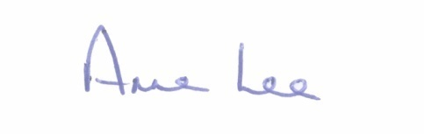

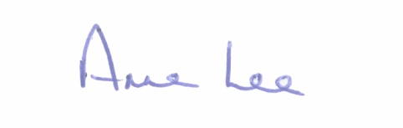
___________________
Anne Lee,
Meetings Administrator.

C L A R

Prayer before Meeting.

- Confirmation of Minutes of Monthly Meeting held on the 9th September 2015 –
copy enclosed

2. Matters arising from Minutes.

3. To note Chief Executive Orders. (Summary herewith)

4. To note Monthly Management Report - report enclosed.

5. To note adopted Minutes of Corporate Policy Group Meeting held on
8th July 2015 - (copy enclosed).
6. Housing, Infrastructure & Emergency Services.

(a) Consideration of disposal of property at No. 3, Lisbrack Longford to Michelle Doherty in accordance with the terms of Section 183 of the Local Government Act 2001 issued on the 23rd September 2015.

(b) Notice of Motion submitted by Councillor John Browne.

"There is a chronic shortage of social housing in Longford town and county with the housing list growing on a weekly basis.
Therefore, I call upon Longford County Council to write to
Mr. Alan Kelly , T.D., Minster for the Environment, Community and Local Government, requesting his Department to provide funding to the Council for the purpose of bringing the following void houses /boarded up houses back into use . The houses are -
32,38,39,41,42,43,46,47,49,50,54,57,61,108,114,116,117, Mac Eoin Park and 81 Annaly Park, Longford , and 12 vacant properties at Redmond Terrace and Colmcille Terrace , Granard."

7. Economic and Community Development, Planning, Corporate, Cultural & Recreational Services, Human Resources.

- To note Planning Applications received since September meeting of the Council.

- Preparation of Register of Electors 2016 – 2017.

8. Finance & Information Systems.

(a) To note Public Liability Claims received during September
2015 – report enclosed.

(b) Consideration of Overdraft Accommodation of €5.5m for year ending
31st December 2016 - report enclosed.

- To note Quarterly Financial Report on Revenue Account – Quarter 2 of
2015 – report enclosed.

(d) Notices of Motions referred from Ballymahon Municipal District.

“That Longford County Council allocates €8,000 to the Lough Ree North Angling Hub towards the World Predator Boat Fishing Competition 2016.”

“That Ballymahon Municipal District call on Longford County Council, when compiling their Budget for 2016, to include specific additional funding to be administered under the Housing or Roads budget for the maintenance and upgrade of roads and footpaths in Council owned housing estates.”

9. General.

- Notices of Motions submitted by Councillors, as listed hereunder –

Councillor Peggy Nolan.

“That Longford County Council hosts a reception to mark the
20 years of excellent service provided by Longford Womens Link.”

Councillor P.J. Reilly.

“That this Council would adopt a resolution in support of Cork City Council in its actions against the proposed merger of Cork City and County Councils, and further supports its challenge to the Local Government Reform programme, which undermines the European principle of subsidiarity. We also direct the Meeting Administrator to inform the Minister for The Environment and Local Government and the Secretary General of the same Department of the passing of this motion by this Council.

Notice of Motion referred from Ballymahon Municipal District.

“That Longford County Council requests Minister Joan Burton to reverse the cut of 66% to CE Schemes Training & Material Budget and reinstate to 2011 levels. These schemes are fundamentally important to rural communities and must be supported. These groups are finding it harder and harder to survive. I also urge Longford County Council to consider increasing the General Municipal Allocation to provide more funding to these important community groups.”

Councillor Mark Casey.

“That this Council sends a letter to the Minister for Health stating that Longford County Council fully support the 3 Key points that The Carers Association have identified in their pre-Budget submission to Government

1. Strengthen the financial safety-net for families who care
2. Strengthen basic services for families who care
3. Support the full-spectrum of family carers

10. Votes of sympathy.

11. Training -

Consideration of Report from Corporate Policy Group.

